**LIMS SHINY Application**

**v.0.1.0**

**A shiny application for creating ImproRisk occurrence templates**

Description and User Manual

**September 2020**

**Nicosia, Cyprus**



Table of Contents

App build specification 2

On load 3

Side bar panel 4

Main panel 7

Aggregated data 7

Raw Data 8

FoodEx1 9

Data Description 10

Download the excel template 11

## App build specification

The app can be found on <https://sglcy.shinyapps.io/lims/>

It hosted on the <https://www.shinyapps.io> server managed by Rstudio [<https://rstudio.com>]

The app is built as a shiny application [<https://shiny.rstudio.com>] and it runs on the R statistical programming language [<https://www.r-project.org>]

The app is built on the R v.3.6.3 and the Shiny package v.1.5.0

## On load

When the app loads, the initial screen is as seen in Figure 1.

Figure 1 Initial screen when app loads

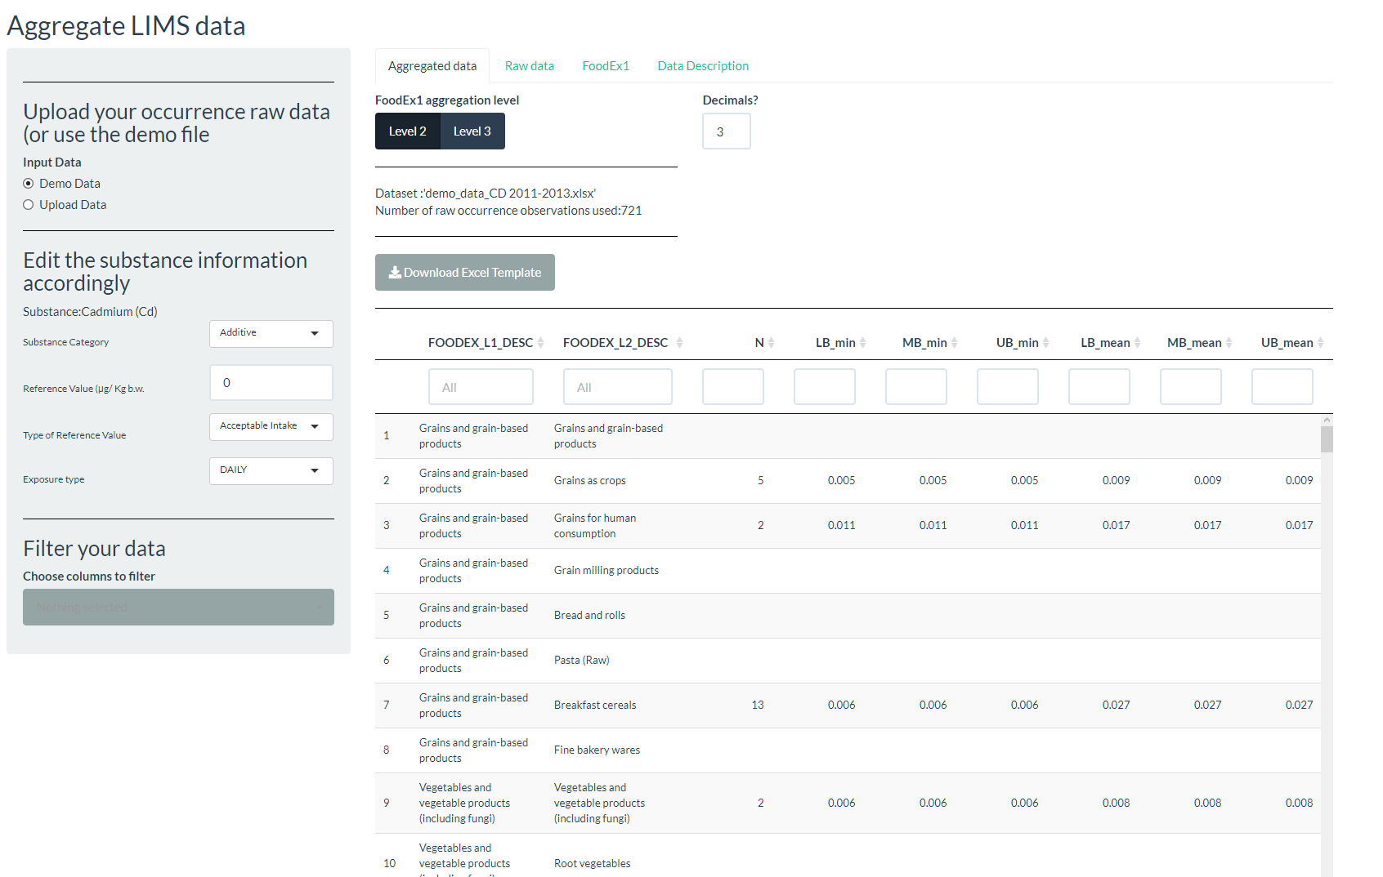

## Side bar panel

On the left, there is a grey shaded side-bar panel (Figure 2) with three sections:

Figure App Side Bar Panel

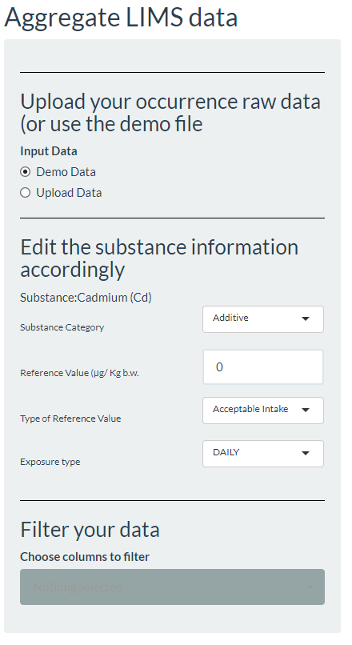

**Section: Upload occurrence data or use demo file**

Here, the user can

a) Use the demo data already installed. These are data for demonstration purposes

b) Upload a dataset to repeat the analysis

**Section: Edit the Substance Information**

After, the user uploads their own set of data, she can fill in this information required by the ImproRisk. This information is not used in the aggregation rather the info is there to be placed in the final exported ImproRisk template for use within the ImproRisk.

The Substance name is automatically picked up from the data. In case the use uploads a dataset with information on more than one Substance, she can filter (keep) only the row data for a single substance using filters (see SECTION: Filter your data)

a) The substance category

The user can select between Additive", "Pesticide", "Veterinary Drug Residue", "Contaminant", or "Genotoxic-Carcinogen"

b) Reference value. The reference value for the substance. This should be numeric value greater than 0.

c) Type of reference value. Select one among "Acceptable Intake", "Tolerable Intake", "Provisional Maximum Tolerable Intake", or "Benchmark Dose Level (BMDL).

d) The exposure type. One of DAILY or WEEKLY

**Section: Filter your data**

Here the user can apply filtering to her data. Filtering in the sense of keeping what you want and reject what is not in our selections.

First, the user can select the columns where to filter on. On click, the user is given the list of column names the data contains to select (multiple selection is available) the columns to filter on. The filter has a build in smart search where options appear as the user types.(Figure 3)

The appropriate filters appear for the user to select particular values from the selected columns. (Figure 4)

Figure UI - select columns to filter on

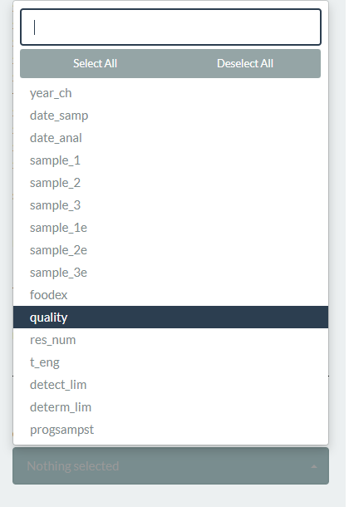

Figure UI - Select the values from the columns to filter the data

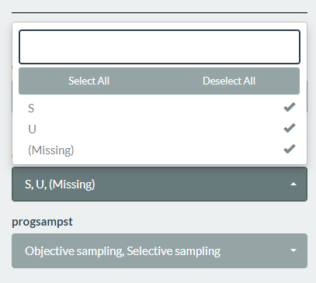

## Main panel

The main Panel (center of the screen) consists of 4 Tabs.

### Aggregated data

Here, the user can view the aggregated data according the FoodEx1 categorization.

Additional options are

a) View the aggregation by Level 2 or Level 3

**Note** that the template is already prepared and contains both the Level 2 and Level 3 aggregations. This tab is for viewing purposes. Of course, if the user filters the dataset using the filters on the SIDE PANEL, the aggregation is recalculated.

b) Set the number of decimals

Increase or decrease the decimal points in the aggregation values.

c) Download the template

Download the template in “.xlsx” format.

Figure Aggregated Data TAB

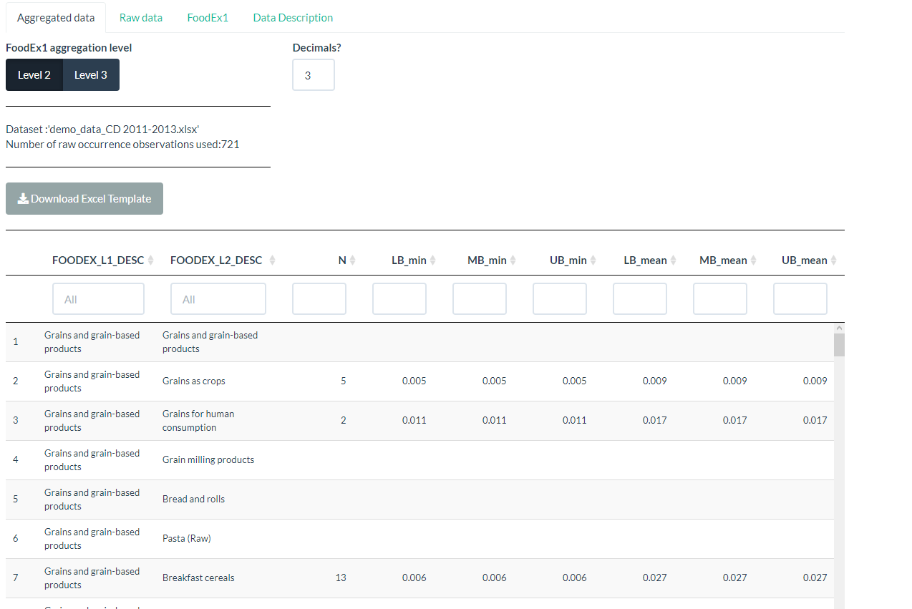

### Raw Data

Here the user can inspect the raw data used in the calculations. These data are filtered according the user’s filtering (if any) on the SIDE BAR Panel.

**Note** that using the table filters (top of the column names) does not influence the aggregation calculations. The table filters have n effect only on viewing the raw data.

Figure Raw Data TAB

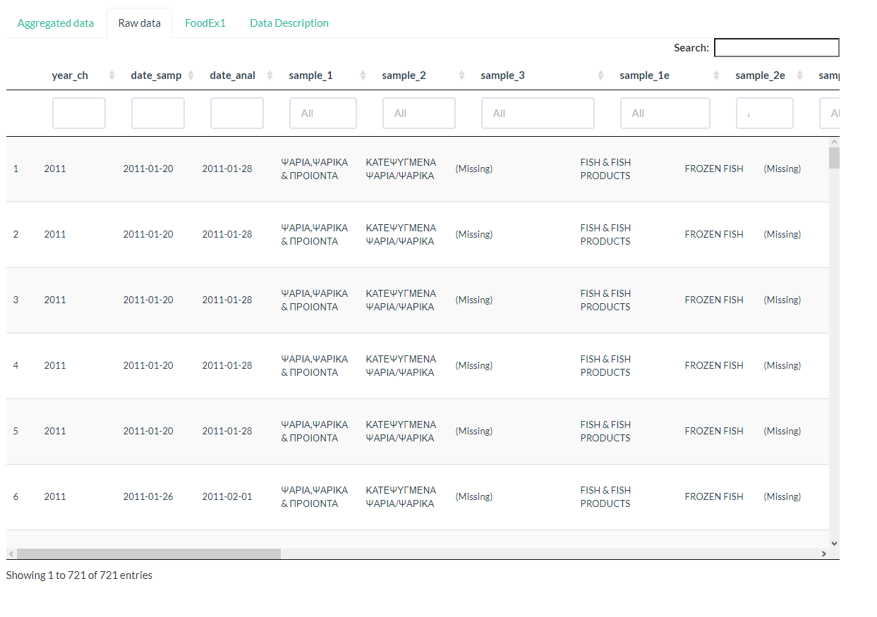

### FoodEx1

This Tab shows the FoodEx1 categorisation hierarchy. The table displays the FoodEx1 code and description on Level 4 thought Level 1.

Figure FoodEx1 TAB

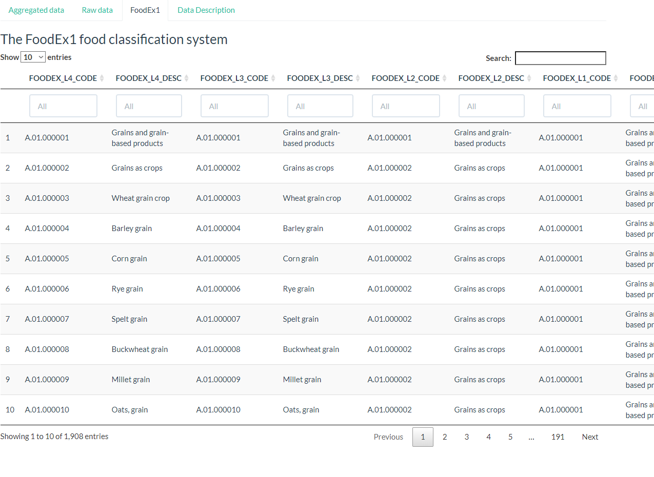

### Data Description

This tab contains the data dictionary for the columns in the demo file that is built in the app.

It serves the purpose of showing the user, the necessary column names (and information they contain) for the app to calculate the aggregations. The user should upload data with at least the columns characterised as “Required” in the third column (Figure 8)

Figure Data Description TAB

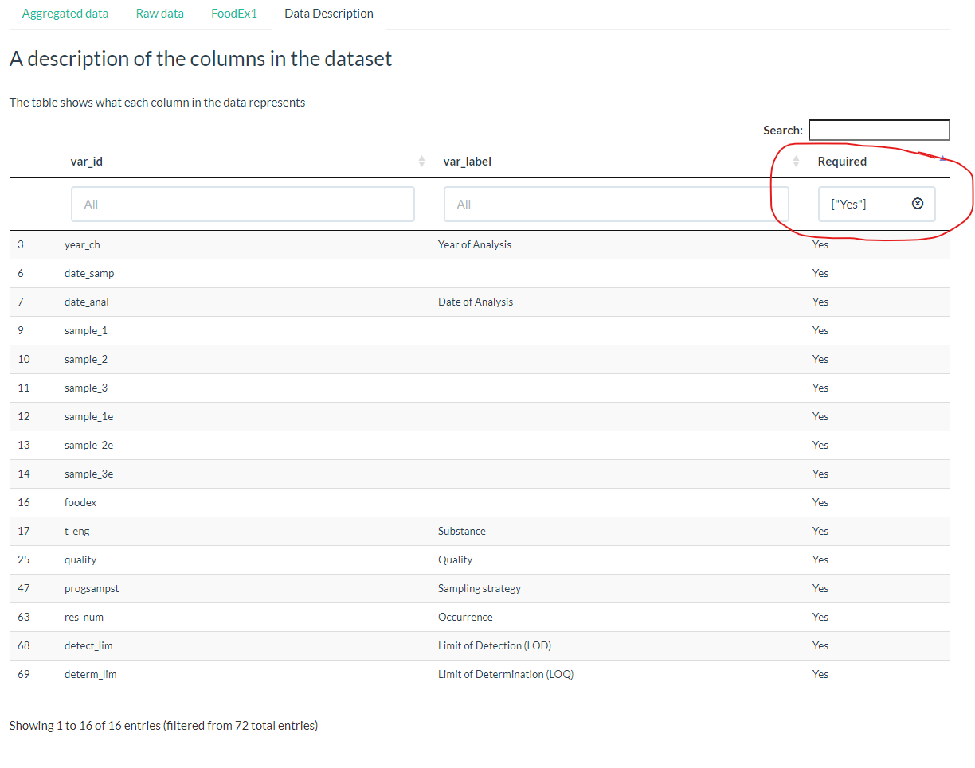

# Download the excel template

In the “Aggregated Data” Tab, the user can download the excel template.

The excel template is an ”.xlsx” file with 2 worksheets (Level 2, Level 3) download in the default download directory of the user’s machine.(Figure 10)

Figure Download Excel Template button

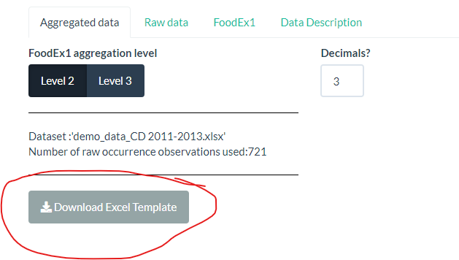

Figure Download excel template

